**Level 1:**

First, we need to check our network configurations. So, then we can find our local ip-address. We use *ifconfig*command to check network. Then we try to gather information of our machine’s local area network to do that we use *nmap* tool.

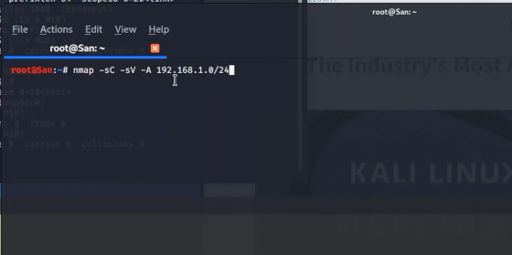

When we nmaping to our local area network all the ip addresses within 192.168.1.0 to 256 will be searching.

*NOTE: this will take several minutes.

(it takes so much time. So, change the nmap command removing the flags. *Nmap 192.168.1.0/24*)

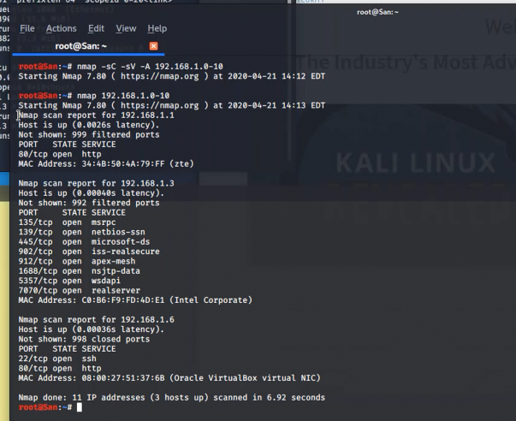

Now there we can find connections that connected to our machine. So, the first result is our router that we use to surf internet. Then the second one is our real local machine that shows mac address like intel corporate. We use virtual box so that’s why it shows our local machine. Then the third one shows like mac address 08:00:27:51:37:6B (Oracle VirtualBox virtual NIC) so that would be the our target.

Let’s nmap that virtual machine ip address. (need nmap tool)

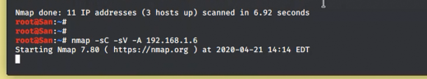

Command – *nmap -sC -Sv -A 192.168.1.6*

These are the information that we gathered.

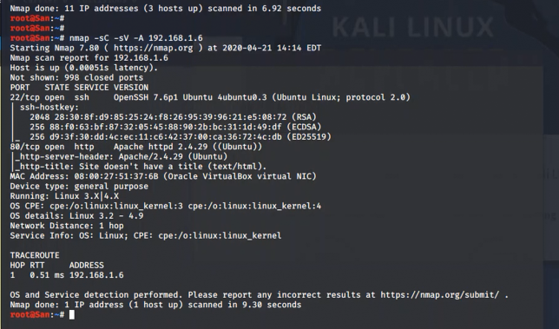

In above figure we can see information like ssh version is Ubuntu 0.3 and OS details likewise. In there we can fine open tcp port 80 which is running apache server. So, let’s assume there is hint to begin. Let’s go to that localhost.

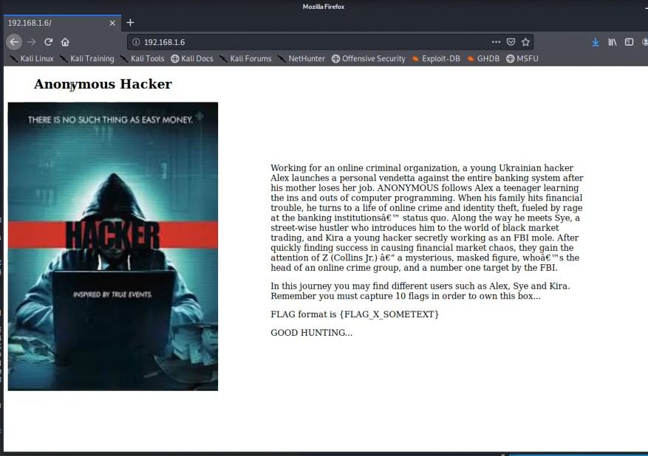

In this host it shows the summary of the Anonymous movie and its characters. Also, there is some special note that says, “In this journey you may find different users such as Alex, Sye and Kira.” So, we can think we need to attack level by level to own this box. And there shows the Flag format so when we see that format in anywhere that would be a flag for next level. So, let’s go hunting.

In there is no other any specific thing. Now we try viewing that page source code.

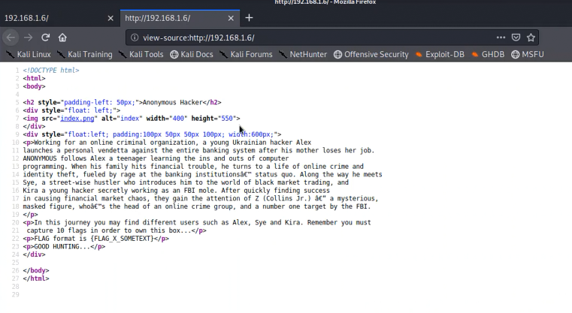

So, let’s look at carefully what we can find there. Actually, there is nothing much than home page. There is source like index.png that is the image that shown in the home page. Then using that index we downloaded the image into desktop folder which name as Anonymous. So, we think that image has something that want that’s why we downloaded it.

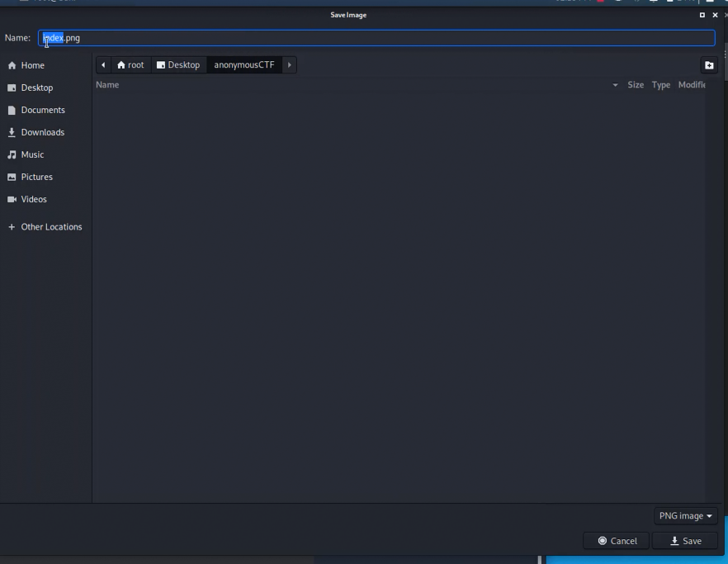

And then we go to that directory in terminal and check the file type of that image.

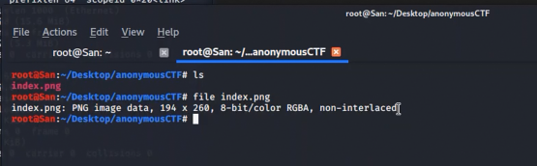

It’s file type is PNG so then we check the strings in that image

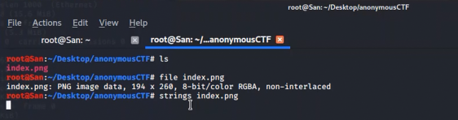

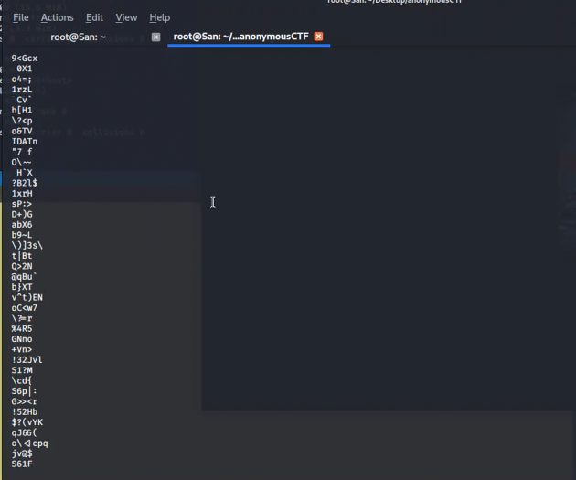

There we got lot of strings. In here we can’t find anything so we try online tool *Steganography decode* at least it would help us. We visited to <http://stylesuxx.github.io/steganography/>

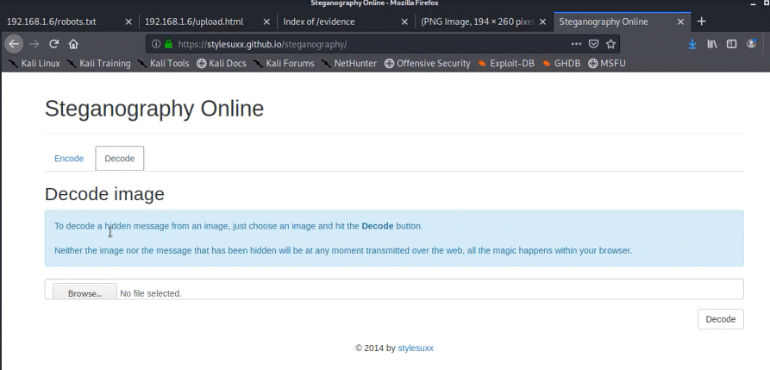

There we uploaded index.png and decode it.

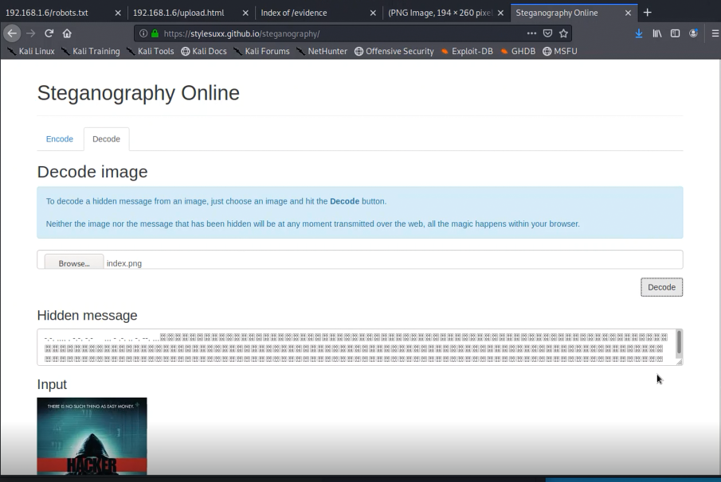

Wow! We decode it and we get some thing that not usually in image decode. So, let’s see about it.



So, to us it is seems like Morse code. So, we try that one using online tool for Morse code into text.

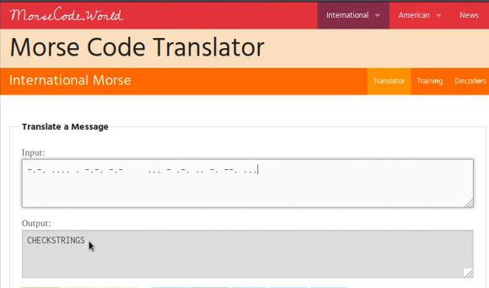

Yes! We got hint. It’s says *checkstrings* but we already checked the strings. We didn’t find anything there. Again, let’s see it with some advance commands.

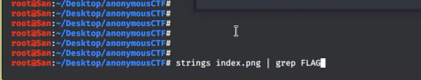

In the home page it says in the flag format there is always flag keyword. So, we did something like this. *strings index.png | grep FLAG*

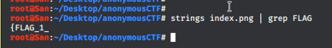

In here we got the half of the flag format. Then where is the other half? Let’s see



We redirect strings into a file and opened it.



Then we got the string in file. So, let’s use find option using keys *ctrl+f* find keyword FLAG.

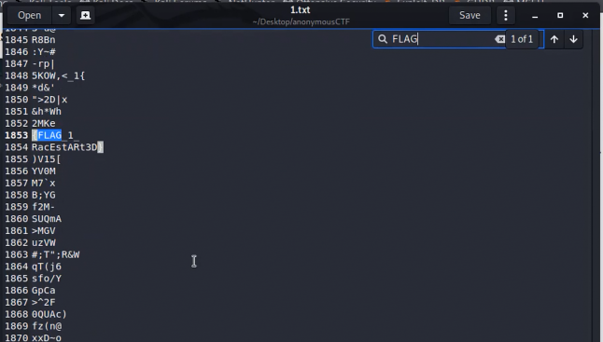

So, there we find the *{FLAG_1_* in the line 1853 and also below that line we see something familiar to read. Let’s see about it. When wen join that two lines it matches to our flag format. So that is the flag for level one.

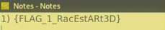

*{FLAG_1_RacEstARt3D}*

*************************************************************************************************************************************************************************

**Level 2:**

Then at the mean time we can find what are the directories hosted in this server. So, when we do it we want dirb tool. Command is *dirb http://192.168.1.6/*

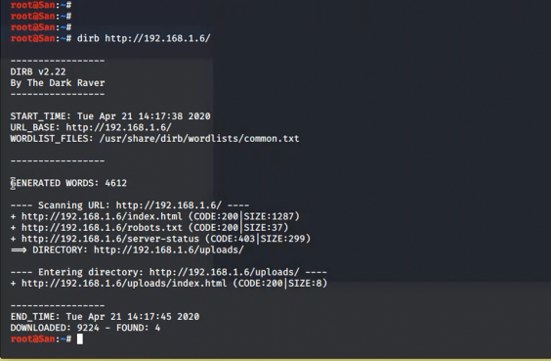

In here we’re getting,

[*http://192.168.1.6/index.html*](http://192.168.1.6/index.html)

[*http://192.168.1.6/robots.txt*](http://192.168.1.6/robots.txt)

[*http://192.168.1.6/server-status*](http://192.168.1.6/server-status) (this response by 403 port so we can leave it.)

And also we got directory called [*http://192.168.1.6/uploads/*](http://192.168.1.6/uploads/) and inside that directory there is some files <http://192.168.1.6/index.html>

So let’s go each by one!

<http://192.168.1.6/index.html>

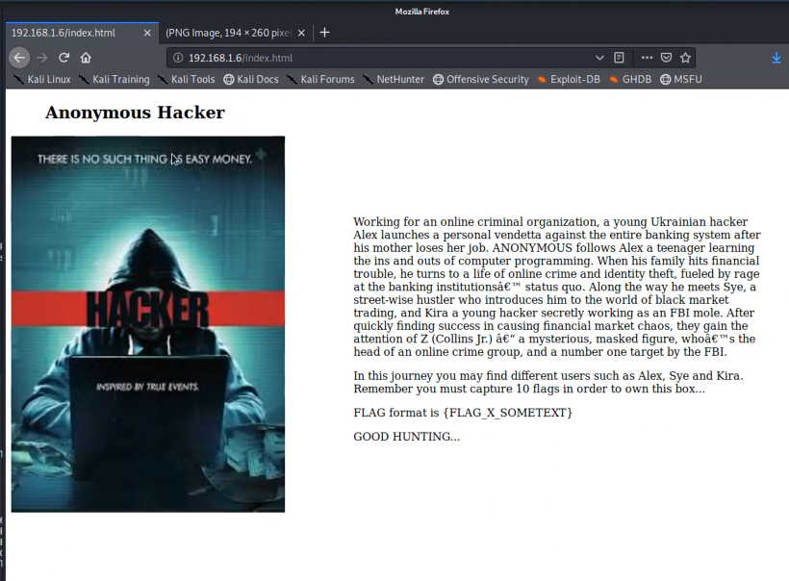

That is the home page. So, let’s move to next one.

<http://192.168.1.6/robots.txt>

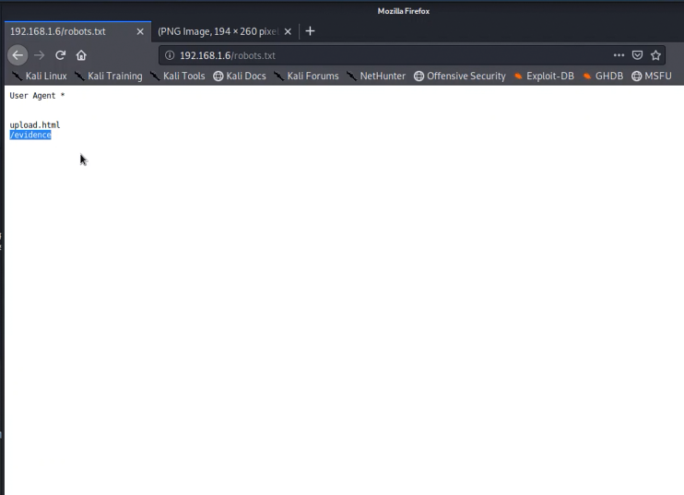

Yes! We found something. That shows another two. *Upload.html and /evidence*

Let’s see what are those?

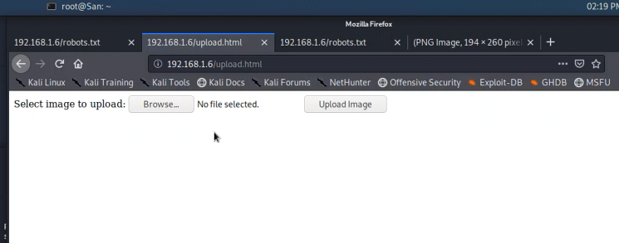

This is upload.html. in here we can upload something. Remember that we can upload anything to this. E.g. reverse shell

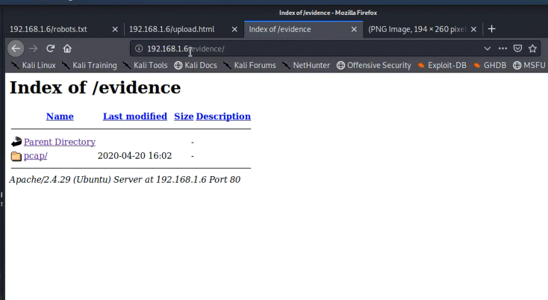

Above one is the evidence directory. And there is folder named *pcap* lets see what’s in that folder.

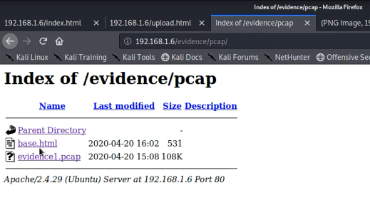

In here we can find two files base.html and evidence1.pcap so we can download the pcap file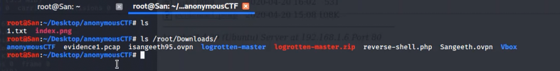

Then we open that pcap file in wireshark so then we can gather the packets and details.



So below is the view of when we open pcap file in wireshark. There we don’t know what we are looking for.

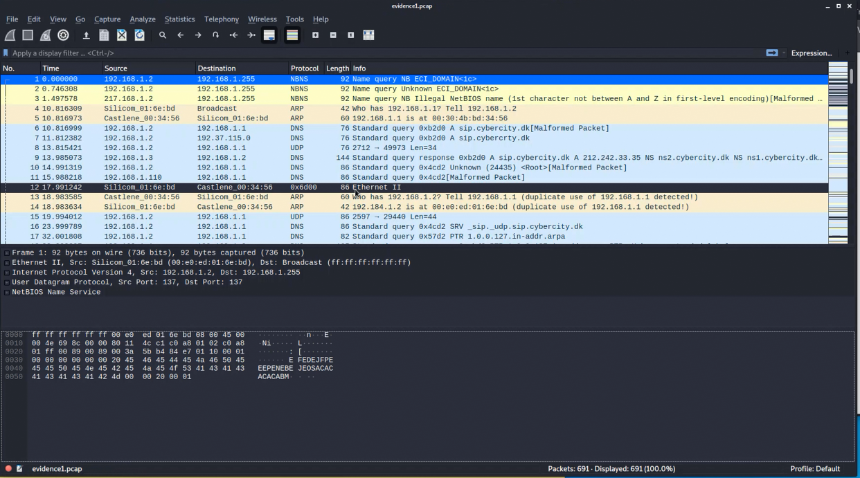

So, we want some hint to find that what we are looking for. So that I open the base.html which is in the pcap folder.

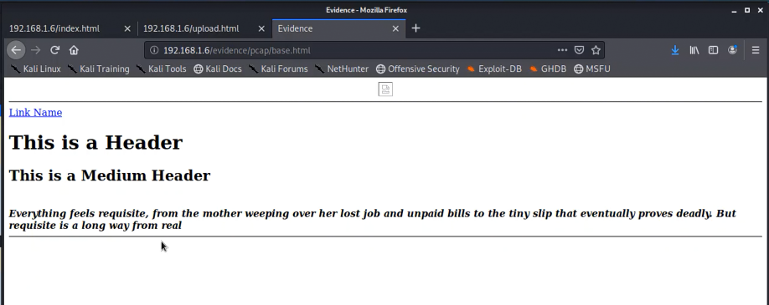

So, this is the it. when we read it, we can’t find anything that we want. So, let’s look at the source code.

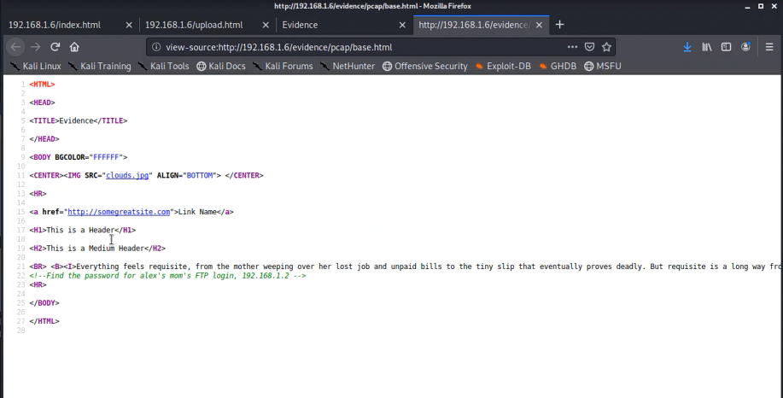

So, there is some sources and some link. When we look at that both files we can’t find instead of styles.

When we read it carefully, in the medium header paragraph there is something comment out. It says “*find the password for alex’s mom’s FTP login, 192.168.1.2”* so in that we have a hint the FTP login. So let’s look FTP packets at in wireshark .

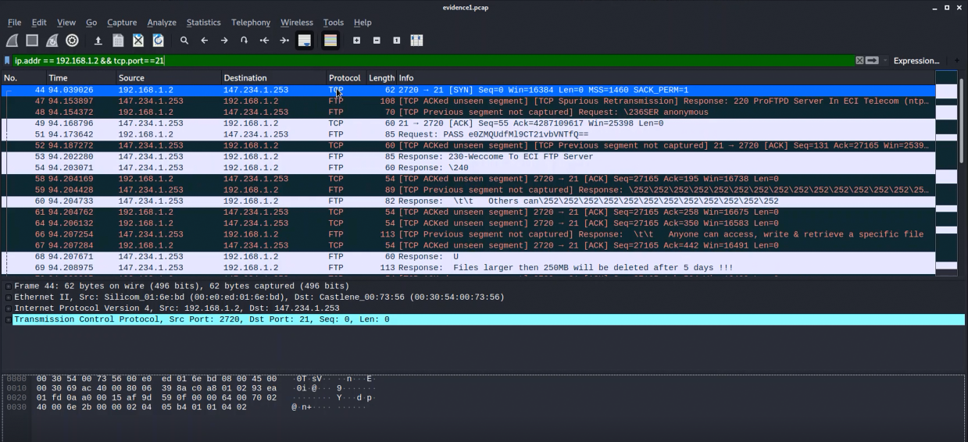

We can filter the packets with our hint. So, we use command to filter

*ip.addr == 192.168.1.2 && tcp.port == 21* in this command it’s filter the all the packets that communicate with 192.168.1.2 ip range and port 21. So, we have some data now. When we look at those packets’ details in length info column there shows details about that packet. And when we look at one by one of the FTP packets. we can find some request like PASS keyword and it’s remained is encoded. So, it looks like suspicious so we follow that one.

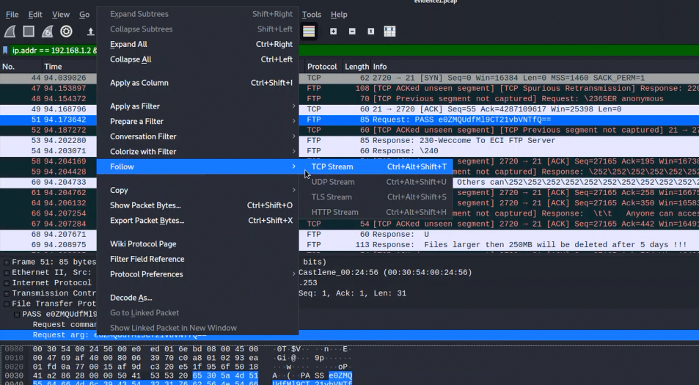

We follow it TCP Stream so then we can see what is in it.

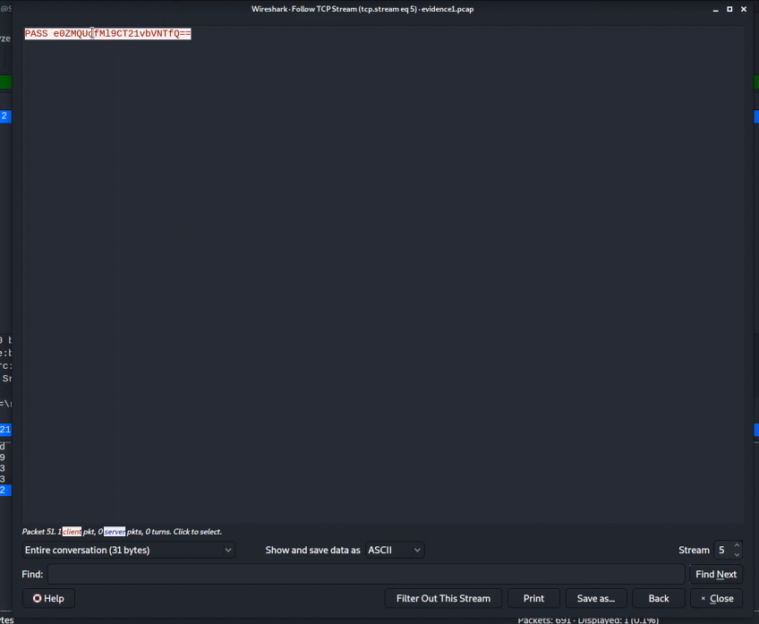

So, the encoded part seems like it’s encoded using Base64 encoding. So, let’s check about it using online Base64 decoder tool or we can check using our kali machine Base64 tool.

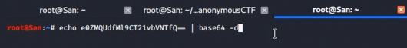

So, we used command: *echo* (copy& paste that encoded part) *| base64 -d*

Then we see about result.

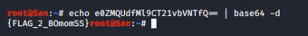

So, it’s the flag for level two.

*{FLAG_2_BOmomSS}*

**************************************************************************************************************************************************************************

**Level 3:**

in our dirb results it shows a directory called [*http://192.168.1.6/uploads/*](http://192.168.1.6/uploads/)So, let’s look about it. Now we visit that directory and look what is in it.

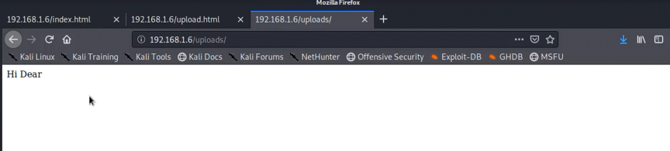

So, there is not much instead of some html text. We assume why there is no anything because we didn’t upload anything using *upload.html* So, now we can upload a image or whatever. So, let’s upload image to check the backend is working.

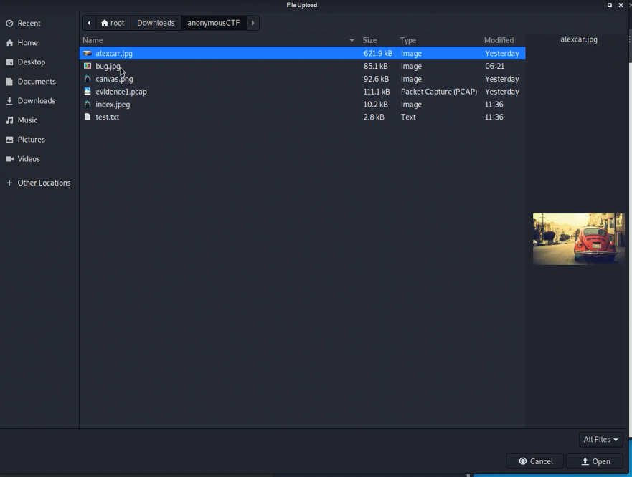

Now we upload this alexcar.jpg to check the backend working successfully. Although if we upload some large file to this maybe backend cannot handle this. So, we want to check it.

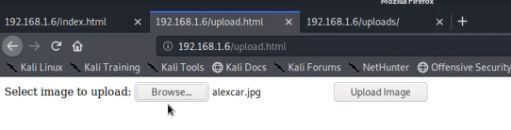

Now we browse the image want click Upload Image button So, let’s do it.

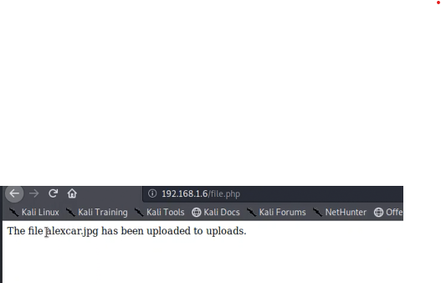

So, it’s says *The file alecar.jpg has been uploaded to uploads.* Now we know backend is working. Ensure that let’s look at the uploads directory.

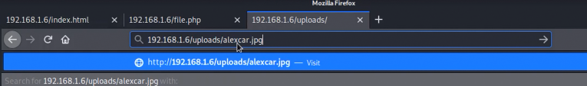

Let’s check that file we uploaded is there.

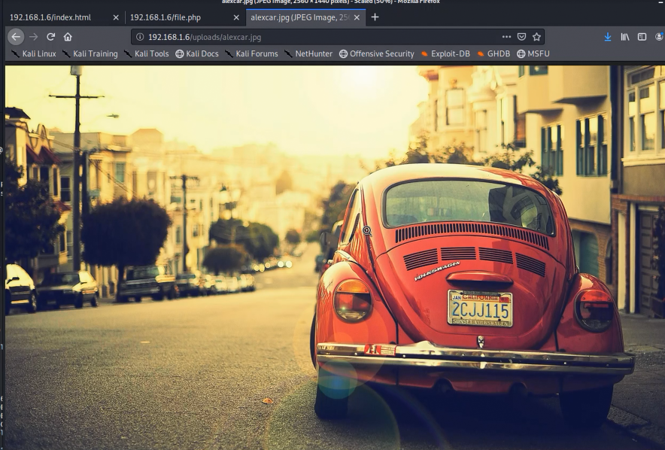

yes! It is there. So, now we know the backend is working. Now we can upload a php reverse shell and get the reverse to our console. Let’s do it. Simply we can download a php reverse shell in the internet.

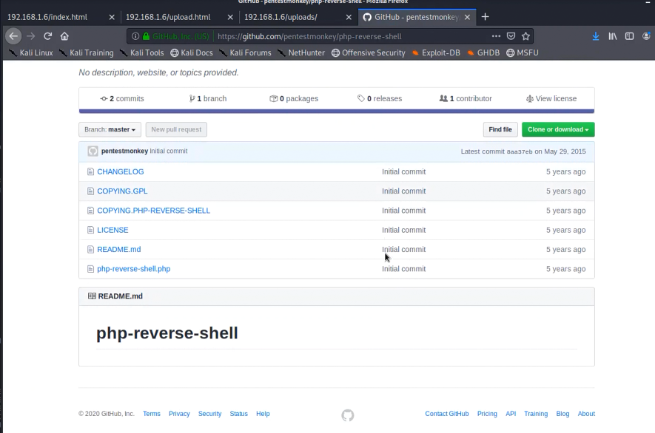

Download a reverse shell from github. But in the reverse shell we need modify some data to it work with our server. So, let’s download it and do the modifications.

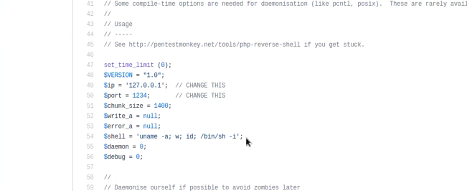

We need to change that comment out lines with our ip address and port. Why we want to do this is we need get response into our machine. So, there only we need to change ip address. Because we can listen to that.

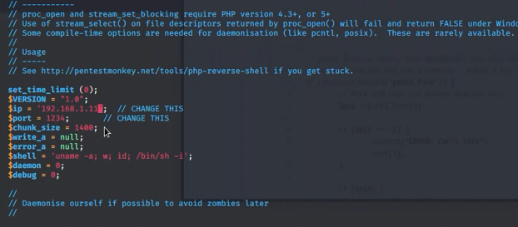

After changing the ip address save and exit. Then we can upload that file. So, let’s do it browse the file and upload it.

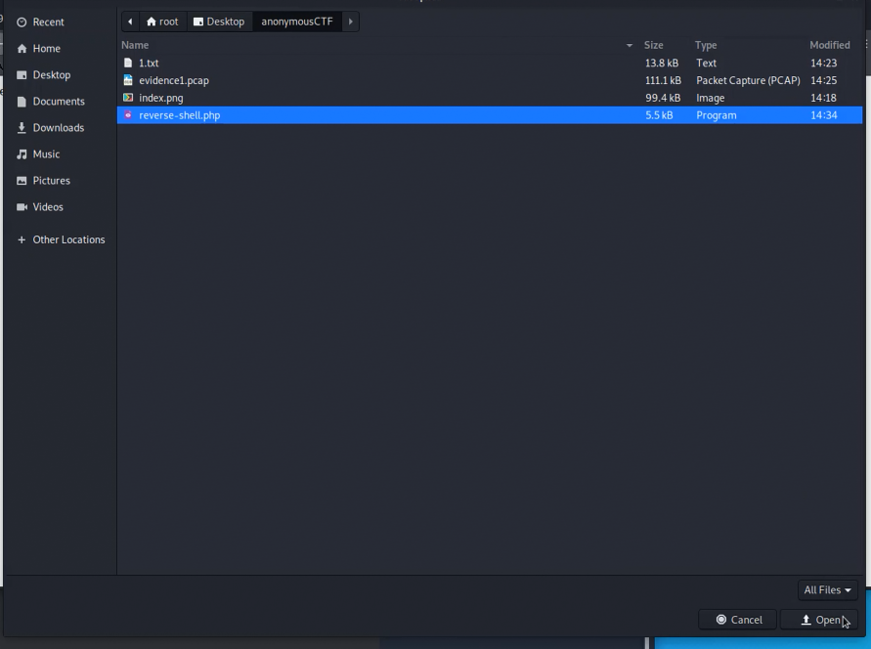

Let’s upload now

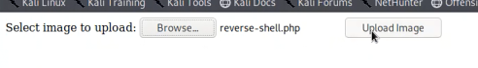

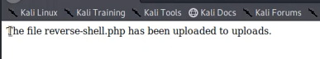

So, now it’s uploaded. So, now we can run the reverse shell.php file. Before run that we can listen to the 1234 port. So, let’s use nmap tool and listen.

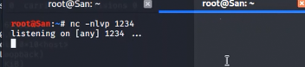

Now we can know the can we get reverse shell or not. So, let’s go to uploads directory and check it.

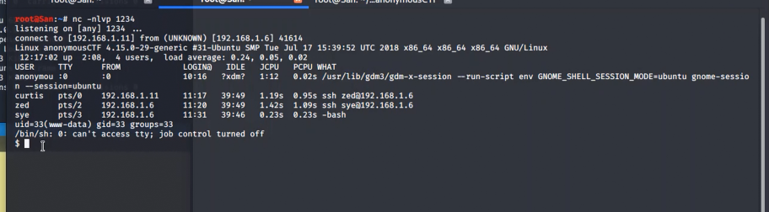

Yes in the backend we are getting reverse shell prompt.

So, now we want do something. First lets check who is the user and user id and what folder is he in. to do that I use following commands like as in the figure.

*Whoami*  - to identify the user

*Id*  - to get uid

ls -ls -to check what is the folder

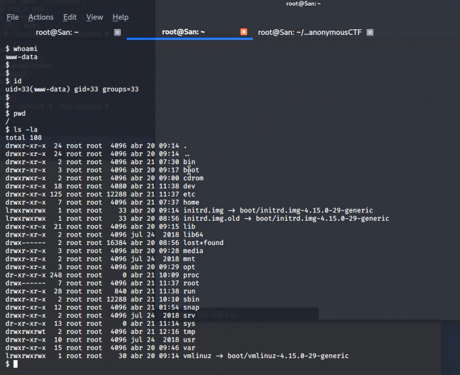

So, we got user as *www-data* and the uid is *uid=33(www-data) gid=33 groups=33* also, the file directory file is root and in the root folder it’s has so many directories. So now we have those details. Let’s check can we see the users file.



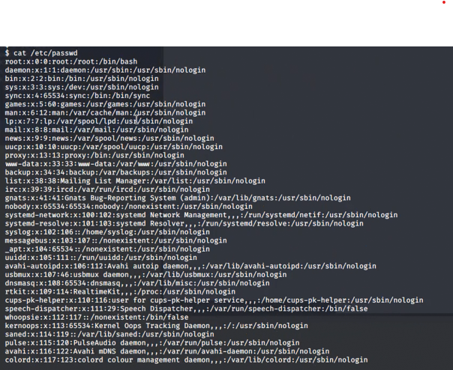

Yes, we can get the users file. Let’s see is there anything that we want. So, bottom in it we can find Anonymous user file. But we actually don’t know it related to our hunting because we just logged in. But under that we can find the users that the homepage mentioned(zed,sye,kira) So now we know this should workout.

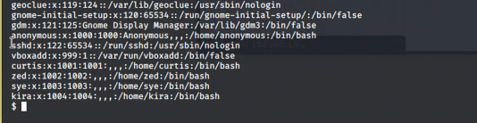

Now we want to check using www-data user what are the directories that we can access. So, let’s do it.



Let’s see what the access are.

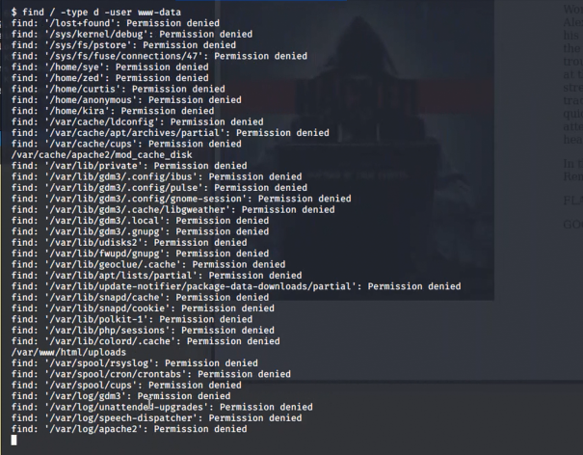

We are getting many directories but most of them are permission denied. And also, there is something important. We want to check the directories that we can access. So, let’s look at those directories. First, we check in /var directory



These are the things that in var directory

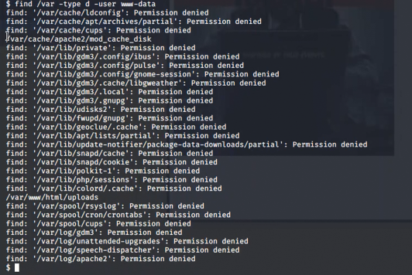

In here we have two directories that can access which are,

*/var/cache/apache2/mod_cache_disk*

*/var/www/html/uploads*

So first let’s look at the uploads directory is that the same directory we upload images and reverse shell.

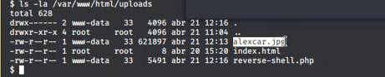

Yes, that is the same directory that we upload images. So, in there is no anything to find. Let’s go to another directory and see what is in it.

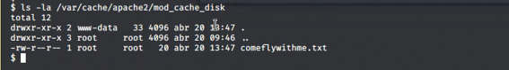

So there we can find text file named *comeflywithme.txt*  but the permission on that file is for root user. But we are not the root user we are www-data. that file is read-only so we just want to see what is in it so then we no need of root user. Shall we read that file.



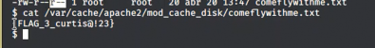

Yes, we got the 3rd flag

*{FLAG_3_curtis@!23}*

**************************************************************************************************************************************************************************

**Level 4:**

We got 3rd flag. So now we see the home directory.

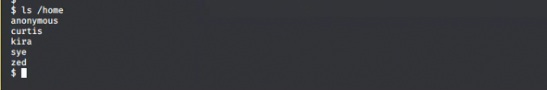

So, these are the folders that created into when making users. Homepage says there is users such as zed,sye,kira so these are that users.

In level 1 we use nmap tool and gathered some information so look at that we can figure out ssh service is already running in this mchine.



Now what we can do is we can try to log into one of the users that we found. In this scenario we found 3 flags. When we look at these flags in the 3rd flag it’s some different other two. It is like password to user Curtis because in the 3rd flag *{FLAG_3_curtis@!23}* it has keyword Curtis. So let’s assume this is the password for user Curtis.

So let’s ssh to Curtis user, command: *ssh* [*curtis@192.168.1.6*](mailto:curtis@192.168.1.6)

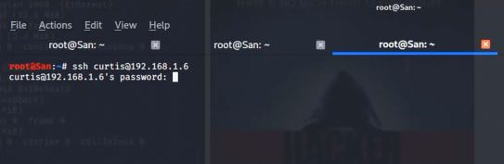

It is asking about password. So, let’s try the full flag *{FLAG_3_curtis@!23}*

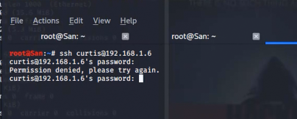

No that’s not the password. Let’s try the keyword *FLAG_3*

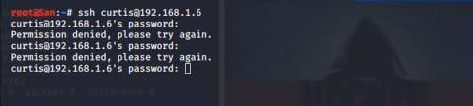

No, that also not the password. Now we try *_curtis@!23*

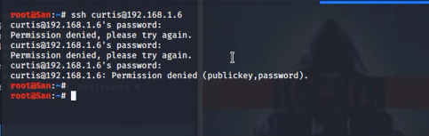

No that is not the password. We have final word. So, let’s try that *curtis@!23*

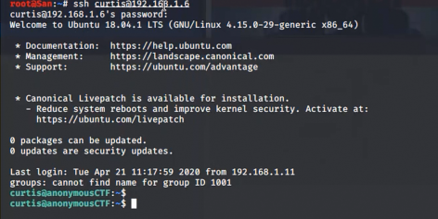

Boom! that is the password. Now we login as Curtis. So, let’s see who I am and what is in this user folder.

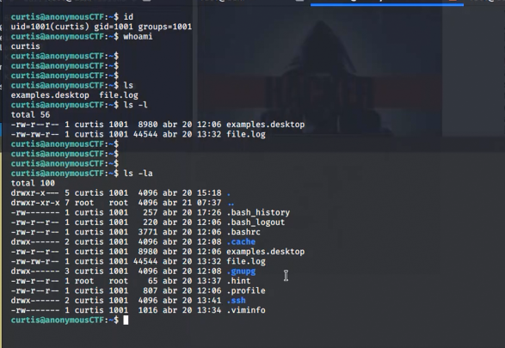

Yes! I am Curtis and this user has some files and also there is some hidden files. Let’s just look at what are those files. We can find there is file hint so let’s see what it is.

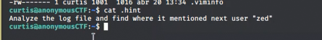

It says *Analyze the log file and find where it mentioned next user “zed”* which means our next user is zed and analyze the log file and find the key word zed. So, there have a file.log so let’s analyze it.

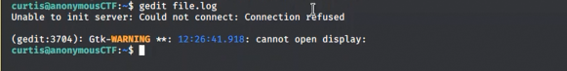

In this case I got an error. Because in this machine there is not installed gedit tool. So, shall we try vim tool.



Then we got a lot of results.

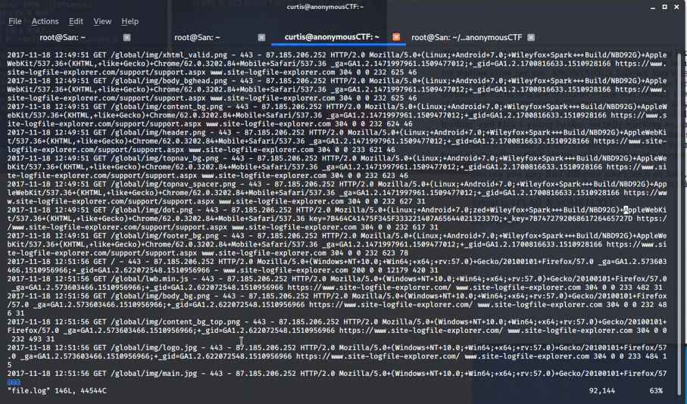

Now we find the zed keyword (use */zed*)



Then we can find keyword called zed and some information.



Then we use *cat file.log | grep zed* command to gather the line which mentioned user zed. So, let’s analyze it. There is a date, there is path, there is a response, there is an ip address, server type, the system, some web links and there have something like “key =” and hexadecimal value. There is two text called key. So, lets convert those hex values into text using online tool.

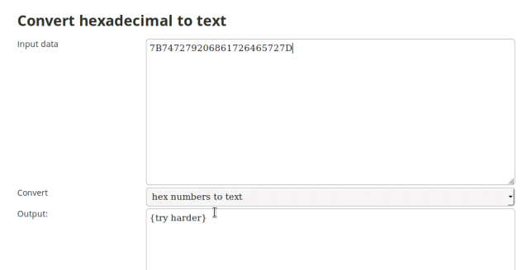

One of that value says try harder. So, let’s try the other one.

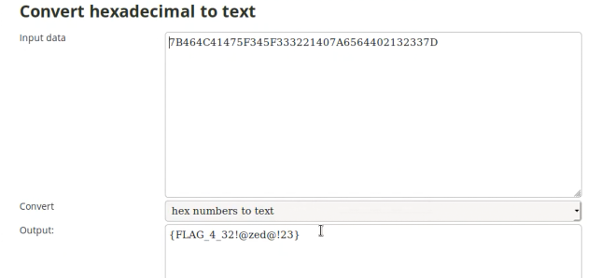

Yes, second one is the flag. And also, we can assume it is the password for the user zed.

*{FLAG_4_32!@zed@!23}*

**************************************************************************************************************************************************************************

**Level 5:**

Now we know the user password with previous level knowledge. So, let’s try that with 4th flag to user zed.

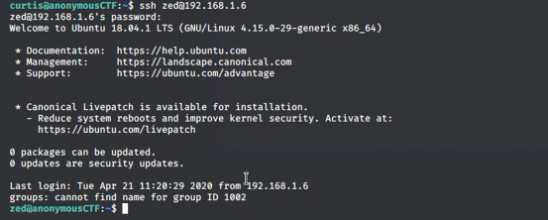

Yes! it works. Password is *32!@zed@!23* so let’s continue..

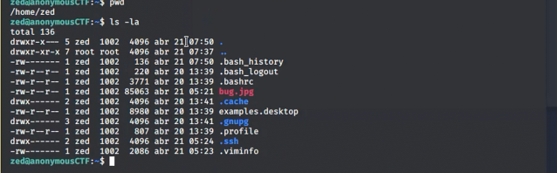

Here I checked the which directory we are in and what are the files in that directory. We found some files in there. In those files there is a image file. Let’s see about that image file if there anything we want.

Let’s check the file type of that.



File type jpg. So, let’s do forensics on that image. For that we need exif tool.

But the thing is in this machine we don’t have exif tool. So, let’s take it to our kali machine from the user zed. In there we can use scp tool for transfer.

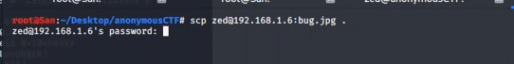

In here it asked about password. Let’s use the user zed password.



Yes, it’s 100% completed. So now let’s use forensics tool with that image.

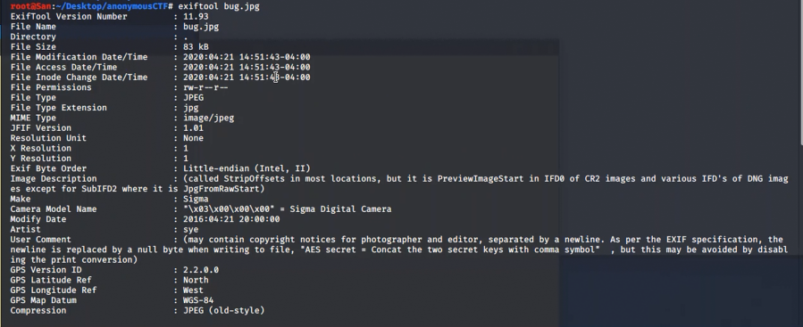

Yes, we got lots of meta data here. Let’s look at one bye one is there any hint.



We found something unusual it says “AES secret = Concat the two keys with comma symbol” which means is the AES secret key is in the meta data there is two keys which concat with “ , ” mark and we can assume in there used a AES encryption mechanism. So, we need to find the two keys to decrypt it. Let’s do that.



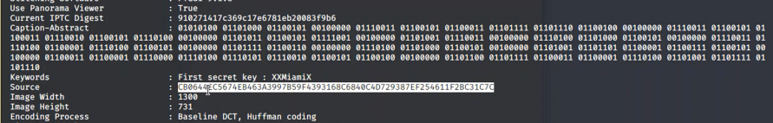

We found a first secret key is *XXMiamiX* so in the hint it’s says concat with a comma symbol. So, let’s modified the founded secret key like *XXMiamiX,* now we want to find the other key. In the meta data we can see like two hexadecimal values and some binary value. Let’s assume one of them are the second key. So, we need to convert those values into text. Let’s do it.

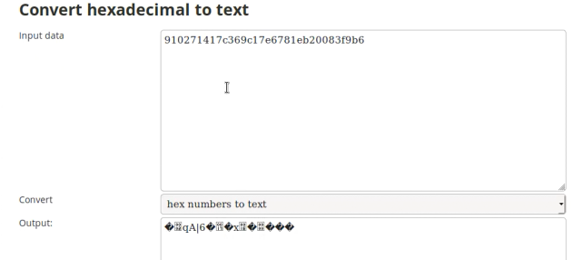

When we use online hexadecimal converter the first hexa value is unidentified format in text. So, let’s try the second one.

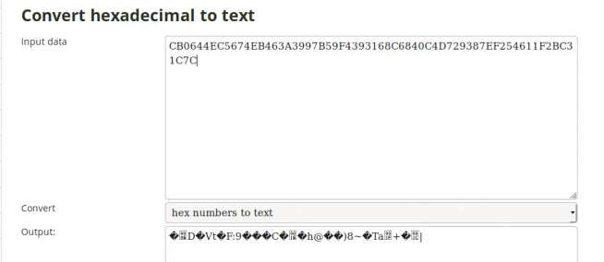

The second hex value also in unidentified format. So, then we can use online binary to text convert tool for convert our binary value.

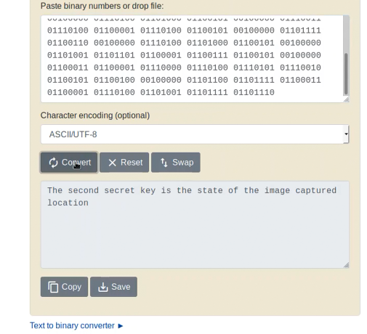

Yes, it says, “The second secret key is the state of the image captured location”. So now we need to get the coordinates in meta data that we got and search that coordinates in google map. And also, the hint says the state of the image captured location. So, we need find the location and we need find which state that location belong to.



We found the GPS position of that image is captured. So, let’s search it in google map.

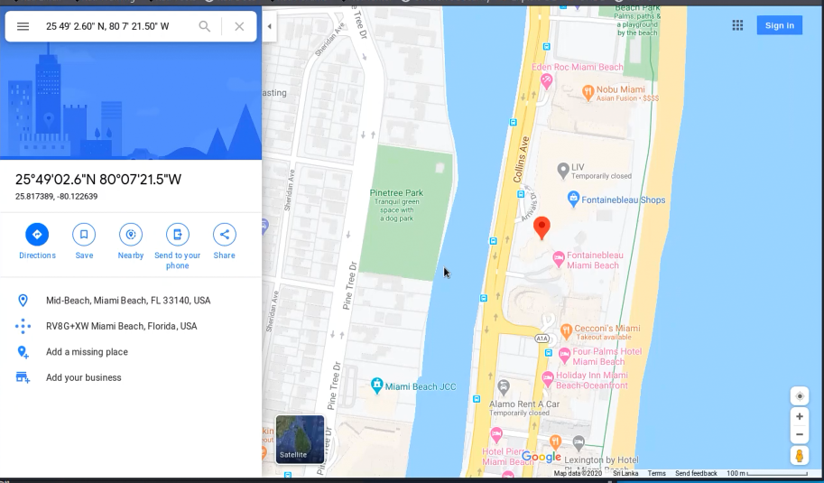

Yes, we found the location of that image captured. Now we want to search that location is in which state. So, the location is Mid-Beach, Miami Beach, FL 33140, USA. Now let’s try to find the state of that location.

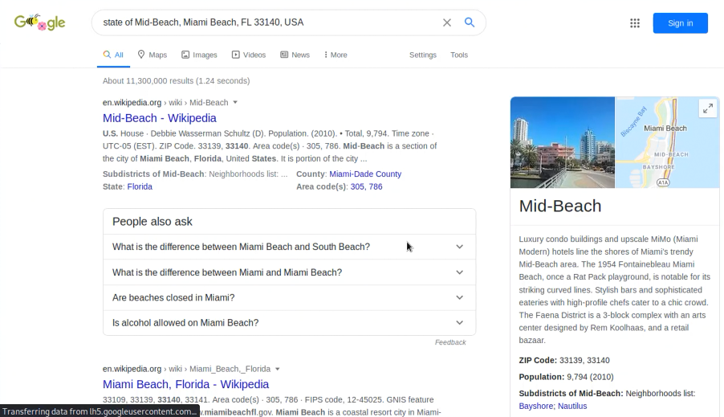

When we use the full address of the location to google search, we can’t find a state. So, there is only three things. Mid-Beach , Miami-Beach and FL 33140. So, FL means florida. Now florida seems like a state. So, let’s search is the florida a state?

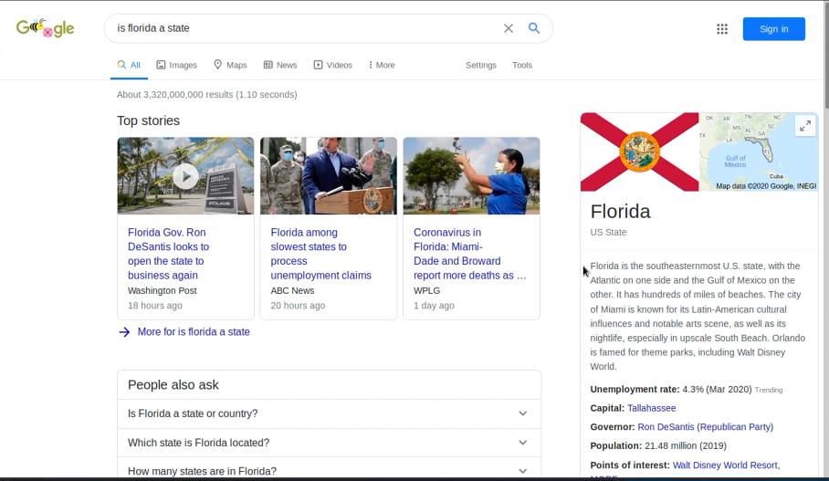

Yes, google says Florida is a state. So, we found our second key. Now let’s combine those two-secret keys with comma.

’

Now this the AES secret key. So now we want do decrypt something using that secret key. Let’s try to decrypt the that hex values and binary value in our meta data. For do that we use online tool for AES decryption.

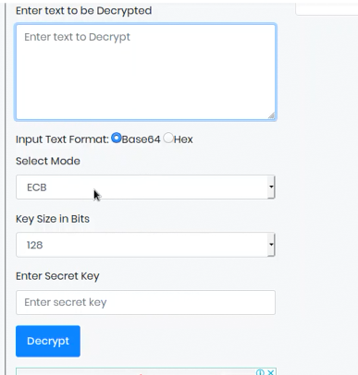

In the online tool it asked to enter text to decrypt. So, the text probably is our hex values. And also, it’s asked the input text format in here we input the hex value, so our format is hex we need to tick to hex. And there asked about key size in bits. So, our secrete key has 16 characters when we calculate the bits of it. It should be 128 bits. And it’s asked the enter secret key so our secret key is XXMiamiX,Florida let’s copy and paste it.

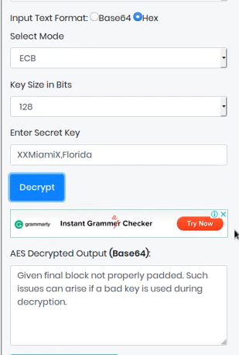

So, we input the first hexadecimal value in our meta data. The output says error massage. So, let’s try the second hex value.

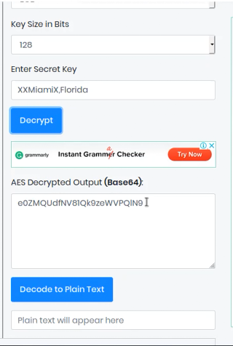

The second hex value is worked, and output is encoded in Base64 format. So now we want to do is decode the output which is in Base64. Let’s try that.

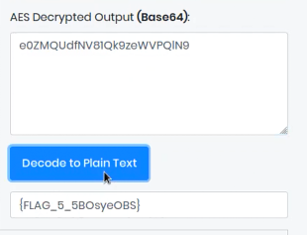

When we decode it we got the 5th flag. So that is it.

*{FLAG_5_5BOsyeOBS}*

**************************************************************************************************************************************************************************

**Level 6:**

So now we know the next user is sye and the password is the 5BOsyeOBS with previous experience. So, let’s try to log into user sye.

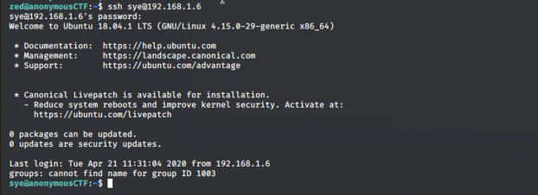

Yes, we log in successfully to sye user. Now shall we check what are the files in our directory.

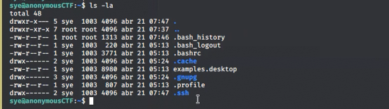

We found some files in that directory. So, let’s look at into one by one.

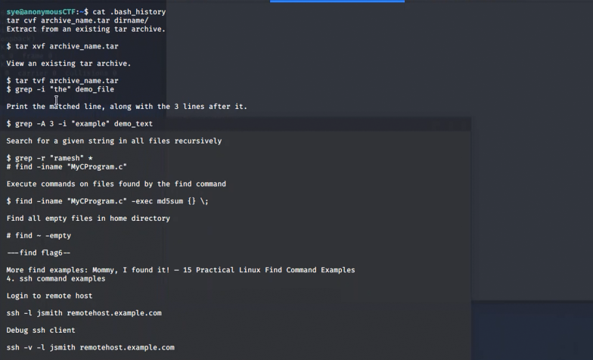

When I check the bash_hsitory file. We’re getting so many information. There are some comments, there is some commands, there is some descriptions. And also, when we look at carefully we can find two hints in those details.



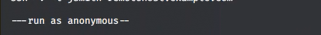

So, it says --- find flag ----- run as anonymous –. Yes, it seems like some hint. So, lets look at that. It says find flag6 so let’s find flag6.



I use above command and output is like this.

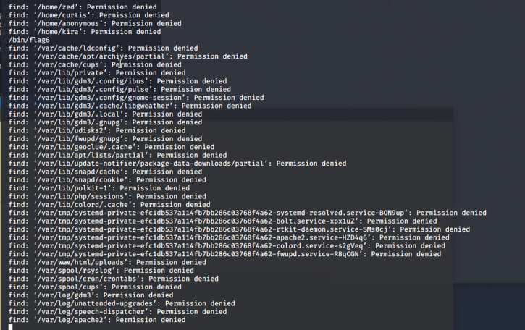

In there so many files have, and permission is denied and also the bin directory we have access. So let’s see what’s in that directory.

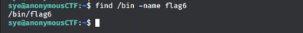

Yes, in the bin directory it has flag file. So, let’s see what is it.

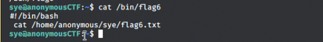

We found a shell script. But it is not containing the .sh extension. So, let’s check it.

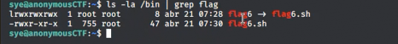

Yes, this flag6 file is smiling to the flag6.sh so let’s see flag6.sh file.

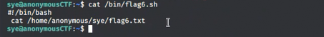

Now we can see the in the cat command there is a flag6.txt so let’s look at it.



Unfortunately, we don’t have access to that directory. But the hint that we found in bash_history it says “*run as anonymous”* so let’s run it as anonymous user.



Yes! We found the flag6. So that’s it.

*{FLAG_6_ADkiraWAN1}*

**************************************************************************************************************************************************************************